PowerPoint and the Internet

Agenda
Pasadena Polytechnic
September 2, 2004
Mary White

10:00 – 10:15 Introductions and objective: A Student Mesmerizing PowerPoint;
or, Ways to Strut your Stuff
10:15 - 10:30 Fashion Show: Sample PowerPoints to inspire you
10:30 - 11:00 Menu Basics: How to Get Around in PowerPoint (Let me Count
the Ways)
11:00 - 12:00 Create slides: For the Do-it-Yourselfer, design your own; or for the busy but discriminating teacher/administrator, Microsoft’s Template Collection
11:30 - 12:00 Accessorizing: Adding Pictures: Clip Art or From Files
12:00 – 1:30 Lunch

1:30 - 2:30 Designer Touches: Adding Custom Animations and Slide
Transitions
2:30 - 3:00 The Latest and Greatest: Adding Hyperlinks

3:00 – 3:30 Saving Your Presentation

Sending in your Online Evaluation (Go to www.schoolnotes.com
Type 74434 in the zipcode box. Click on my name (WHITE).
Choose the first link, Polytechnic. Fill out the survey. 4 is a really good answer.
Your Assignment:

- Put together a PowerPoint slideshow to use in your classroom.
- It should have at least 5 slides
- It should have an attractive background.
- It should have at least one appropriate picture.
- It should have at least one hyperlink.
- It should have attractive slide transitions.

Quick Starts PowerPoint XP

To add a new slide:

- Insert>New Slide
- Click the thumbnail slide (in the left pane) and click ‘Enter”
- Control +M (Control + N gives you a whole new presentation)

To use Microsoft’s pre-designed templates:
- Format>Slide Design
- Click on choice from slide design pane, right side of screen

To change the background color:
- Format > Background
- Pull down arrow lets you choose many fills
- Choose “Apply to All” to add this background to all slides
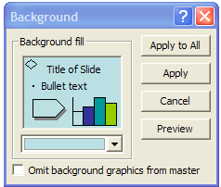
- Choose “Apply” to add this background only to the current slide

To add a picture:
- Insert>picture
- Choose “clip art” to find a graphic from Microsoft’s collection
  - On the right pane, enter a search term; or
  - Choose “clips online” for lots of choices
- Choose “file” to use a picture you have on your computer or have on your camera
To add a text box:
- Insert>text box
- Choose horizontal or vertical
- Draw the text box
- Rotate by grabbing the green circle
- Position by clicking and holding the border area and dragging

To add animations:
- Slide Show>Animation Schemes
  - This choice lets you apply animations to one or more slides
  - The right task pane gives you the choices
  - Use this for quick and easy glitz
  - You can also use the pull-down window in the right task pane to choose this command
  - Use the Play command to preview
- Slide Show> Custom Animation
  - Use this choice when you want to design your own slide happenings
  - The right task pane gives you choices and choices and more choices
  - Note that custom animations apply only to the slide you are working on
  - You can apply custom animations to text, pictures or any other object

To add slide transitions:
- Slide Show>Slide Transitions
- The right task pane gives you the choices
- Be sure to click “apply” or “apply to all”

To work in outline view
- Click the “Outline” tab in the left task pane
- Type your outline: remember not to put too much text on one slide
- Decide on a template and apply
- Voila! Your PowerPoint is ready to go.
- Be sure to check each slide before you use it; some of the text may move around when you change templates.

To add a hyperlink:
- Type a web address (http://4oops.com) in a text box. Touch “enter” to make it “hot”
- Or, select text or a picture. (Drag across text; click on a picture once.)
- Choose Insert>hyperlink
- Type the web address in the address box.
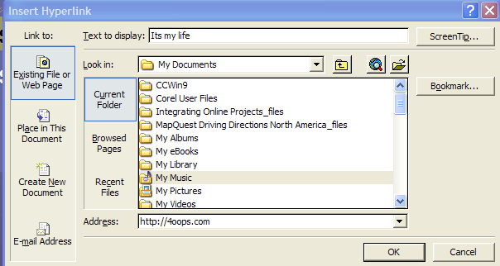

Great Internet Links For More PowerPoint POWER

- ActDen http://www.actden.com/pp/index.htm This site is a free, easy-to-use, basic tutorial for PowerPoint and other Office Applications

- Microsoft Education Powerpoint Lessons http://www.microsoft.com/Education/Flowcharts.aspx This site has many ways to use PowerPoint in your classroom

- Templates http://office.microsoft.com/en-us/templates/CT011323751033.aspx This site has PowerPoint templates for teachers.

- Backgrounds for Teachers http://www.brainybetty.com/educators2.htm or http://www.brainybetty.com/educators1.htm This site lets you download neat backgrounds. (It won’t work in Windows 98 unless you have WinZip)

- Also check out Brainy Betty’s homepage: http://www.brainybetty.com/MENUEducators.htm since there are lots of other useful links here

- OOPS’ MS Office links for Terrific Teachers: http://www.oops.bizland.com/msofficelinks.htm Many great PowerPoint links when you want a little more pizzazz in your presentation

- OOPS – http://4oops.com Check out the free clip art links

- Sound Files http://www.webplaces.com/html/sounds.htm or http://thefreesite.com/Free_Sounds/Free_WAVs/index.html. These files are free and can be used if you need sounds. Best for more advanced users.

