 OOPS: Our Overnight Planning System

Staff Development Training

AGENDA

Port Arthur Independent School District

Helen Teague, MEd.

Going On A WebQuest



Objective: To Navigate the Cyber Jungle, Wise Travelers Need a P*A*L: (Project, Activities, LessonPlan)

“Going On A WebQuest”
P*M*I Analysis

Introduction to Internet Integration, Online Activities

“Jungle Wanderings”
Points of Interest along the Trail: Sample Projects

“Mapping the Trail”
Tips and Tricks to Troubleshoot and Triumph

Lunch

“Jungle Provisions”
Using Template Files
Creating a WebQuest

Editing the WebQuest/Adding Links

“Around the Campfire”
Sharing with Colleagues
Evaluations and Conclusions

FAST FOOD FRENZY

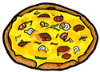

INTRODUCTION

Fast Food Frenzy
It is almost lunch time and you are daydreaming about where you and your friends will go for lunch when that bell finally rings. McDonalds? Taco Bell? KFC? Chick-fil-a? Wendy's? What will you order? Burger and fries? Grilled Chicken and a salad? Burrito? Should you supersize it? Get the Biggie fries? How about a Jumbo Mountain Dew to wash it down? So many choices but do you really know what is in that burger and fries and what it could be doing to your body? Today's teens certainly have a different lifestyle than teens did 20 years ago. They live in fast times with fast paced lives. Many families do not plan, prepare, and eat meals together due to work and the schedule of other responsibilities. Teens find themselves eating on the run and fending for themselves all too often. On any given day one in four Americans visits a fast food restaurant. McDonalds serves 47 million customers each day. Americans spend more on fast food than on movies, books, magazines, newspapers, videos, and recorded music- combined. We even spend more money on fast food than on higher education, personal computers, computer software or new cars! Over 110 Billion dollars a year! So what is everybody eating? Is it really all that bad? Is it possible to eat a healthy diet at fast food restaurants?

Task:
You will be analyzing your favorite fast food meal to determine what your choices are providing for you in the way of nutrients and calories. You will then investigate how to make healthier choices when dining at fast food restaurants. This information will be presented in an Inspiration graphic organizer. After finding out some possible ideas for eating healthy you will plan a healthy fast food meal from a restaurant of your choice. Your final task will be to write an essay responding to the original question: Is it possible to eat a healthy diet at fast food restaurants? You will need to defend your answer with information you have learned in this quest.

Process:
1. Read the article, Fast Food Facts, http://www.olen.com/food/book.html
and record the dietary recommendations on the Fast Food Frenzy worksheet.

2. Using the Fast Food Frenzy worksheet, record your favorite fast food meal.

3. Analyze your meal using the nutritional information from the following websites. Fill in the information on the chart printed on the Fast Food Frenzy worksheet.

Arby’s http://www.arbys.com
Burger King http://www.bk.com/
Dairy Queen http://www.dairyqueen.com
Dominos http://www.dominos.com
KFC http://www.kfc.com
McDonald’s http://www.mcdonalds.com
Pizza Hut http://www.pizzahut.com/
Sonic http://www.sonicdrivein.com
Subway http://www.subway.com/
Taco Bell http://www.tacobell.com/
Wendy’s http://www.wendys.com/
The Fast Food Nutrition Fact Explorer http://www.fatcalories.com
Fast Food Facts http://www.foodfacts.info/

4. The last row of the chart requires you to calculate the percentage of daily totals. This is calculated by dividing the total number you consumed in the meal by the recommended amount (which you listed at the start of the worksheet). If a nutrient has a range for its recommendation, use the largest number in the range.

5. Now it is time to investigate making healthier choices at fast food restaurants. Read the articles at the following links:
Fast Food Nutrition/Healthy Restaurants http://www.helpguide.org/life/fast_food_nutrition.htm
Eating Lean on the Run http://www.healthyheart.org/nutrition/EatingLeanOnTheRun3.pdf

6. Organize the information from the previous sites using to create a graphic organizer. The center bubble of your graphic organizer should be entitled, “Eating Healthier at Fast Food Restaurants.” You need to include at least 8 pieces of information in your organizer that you feel would help in making healthier choices when dining at fast food restaurants.

7. Create a menu for a healthy fast food meal from a restaurant of your choice. Fill in the chart on your Fast Food Frenzy worksheet using the following websites:
Arby’s http://www.arbys.com
Burger King http://www.bk.com/
Dairy Queen http://www.dairyqueen.com
Dominos http://www.dominos.com
KFC http://www.kfc.com
McDonald’s http://www.mcdonalds.com
Pizza Hut http://www.pizzahut.com/
Sonic http://www.sonicdrivein.com
Subway http://www.subway.com/
Taco Bell http://www.tacobell.com/
Wendy’s http://www.wendys.com/
The Fast Food Nutrition Fact Explorer http://www.fatcalories.com
Fast Food Facts http://www.foodfacts.info/

8. Calculate the percentage of daily totals as you did for your favorite fast food meal.

9. Now it is time for you to decide your answer to our original question: Is it possible to eat a healthy diet at fast food restaurants? On a piece of paper, write a paragraph responding to this question. Be sure to defend your answer.

10. Turn in the following to your teacher:
1. Fast Food Frenzy worksheet
2. Graphic Organizer
3. Paragraph

Conclusion:
You have made it through the, “Fast Food Frenzy!” With today’s fast-paced lifestyles it is probably unrealistic to think any of us could give up fast food completely but we can sure do a lot better job of making selections from the menu. Knowing a little more about the nutritional value of what you eat at a fast food restaurant will you order differently the next time you visit one? You have the knowledge to make healthier choices when you go out to eat. Make sure you keep in mind what you have learned the next time you take a drive through the drive-thru!!

FAST FOOD FRENZY
RUBRIC
Name: ________________________ | Teacher: __________________

Date : ___________________

 | Criteria | Points

 | 1 | 2 | 3 | 4
Fast Food Frenzy Worksheet: Completion | Worksheet is incomplete. Most of the information is incorrect. | Worksheet is somewhat complete. More than one section has incorrect or incomplete data. | Worksheet is mostly complete. | Worksheet is complete. All sections are filled out accurately. | ____
Fast Food Frenzy Worksheet: Healthy Choices Fast Food Meal | Food choices are not appropriate for a healthy menu | Some food choices are appropriate for a healthy menu. | Most food choices are appropriate for a healthy menu. | All food choices are appropriate for a healthy menu. | ____
Graphic organizer | Less than 3 accurate facts are displayed on the graphic organizer. | 3-4 accurate facts are displayed on the graphic organizer. | 5-7 accurate facts are displayed on the graphic organizer. | 8 accurate facts are displayed on the graphic organizer. | ____
Paragraph | Paragraph does not support the position taken on the question. AND/OR the evidence(facts, statistics, examples, real-life experiences) and examples used are not relevant. | Paragraph supports the position taken on the question with minimal(1) examples or evidence.(facts, statistics, real-life experiences) | Most of the evidence (2-3) and examples are specific, relevant to support the position taken on the question. | Paragraph includes 3 or more examples or evidence(facts, statistics, examples, real-life experiences) that are specific and relevant and explanations are given that support the position taken on the question. | ____
Use of Work time | Wastes Work time- Ignores prompts to stay on task. | Did some work but had to be reminded often to stay on task. | Completed work with minimal reminders to stay on task. | Efficient use of work time. No prompts needed to stay on task. | ____
 |  |  |  | Total----> | ____

Teacher Comments:

Powered by TeAch-nology.com- The Web Portal For Educators! (www.teach-nology.com)

Name: ______________________________ Period: _________ Date: ___________

FAST FOOD FRENZY

List daily intake recommendations for the following :
1. Calories:
Male:
Female:
2. Fat:
3. Cholesterol:
4. Sodium:

FAVORITE FAST FOOD MEAL

Restaurant: ______________________________

Food | Serving Size | Calories | Fat | Cholesterol | Sodium
Totals:
% of daily totals

HEALTHY CHOICES FAST FOOD MEAL

Restaurant: ______________________________

Food | Serving Size | Calories | Fat | Cholesterol | Sodium
Totals:
% of daily totals

WebQuest Planner
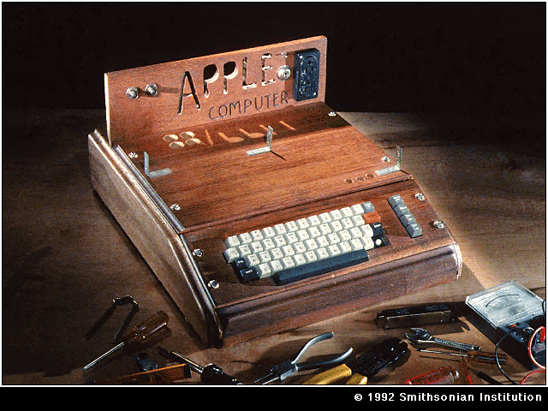
Introduction: Hook

You are part of a design team to build a better computer.

Task:

Process

First

Next

Next

Next

Resource URL’s:

Conclusion:
WebQuest Planner

Introduction: Hook

Task:

Process

First

Next

Next

Next

Resource URL’s:

Conclusion:

WebQuest Website References:

Find websites to use in your classroom using these tools:

- The WebQuest Site: http://webquest.org
- For Grades 3-5: http://www.eduscapes.com/sessions/travel/k3webquests.htm
- For Grades 3-6: http://www.eduscapes.com/sessions/travel/36webquests.htm
- For Grade 7-12: http://www.eduscapes.com/sessions/travel/mhswebquests.htm
- Lit-Based: http://webquest.sdsu.edu/literature-wq.htm
- Or use a search engine such as Google (www.google.com ) and enter your topic + webquest→ copyright + webquest

Create your own webquest with this template:

1. Teach-nology: http://teachers.teach-nology.com/web_tools/web_quest/

Here is our online powerpoint:

1. From The OOPS Page: http://www.oops.bizland.com/webquests.ppt

2. And here is Kathy Schrock’s PowerPoint on WebQuests:
http://discoveryschool.com/schrockguide/webquest/wqsl1.html

